**THE LORD OF THE RINGS: THE RETURN OF THE KING in Concert**

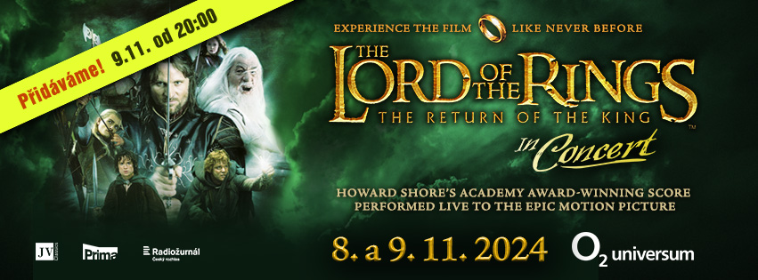

***THE LORD OF THE RINGS: Return of the King***

***Friday 8. 11. 2024 at 7.30pm & Saturday 9. 11. 2024 at 2.30pm and 8pm***

***O2 universum Praha***

**The journey of "The Fellowship of the Ring" is over, the decisive battle for Middle-earth begins! Enjoy the dramatic conclusion to the trilogy in a unique cinematic performance with live music by Oscar-winning composer Howard Shore, performed by a 230 member musical ensemble - the Czech National Symphony Orchestra, the Charles University Choir, Prague Philharmonic Children’s choir and international soloists.**

The concert with a spectacular film screening will take place twice, on 8th and 9th November in the modern concert hall O2 universum Prague.

After the two hopelessly sold-out *The Two Towers* concerts in March 2024 and the two *Return of the King* concerts on 8 and 9 November 2024, a third concert has been added to satisfy the audiences. It will take place on 9 November at 8pm.

The Lord of the Rings: The Return of the King, based on the book by J. R. R. Tolkien, premiered in the Czech Republic on 15 January 2004. Its attendance reached three quarters of a million spectators. Although more than 20 years have passed since its release, this ground-breaking work has lost none of its popularity. On the contrary, more and more new generations admire its excellence. Howard Shore, who won two Oscars for The Fellowship of the Ring and The Return of the King, composed the beautiful music for the trilogy. The third Oscar was awarded to the final song of the saga, Into the West, sung by the famous Annie Lennox.

*"The large scale of the music requires a symphony orchestra, a mixed choir, a boys' choir and instrumental and vocal soloists singing in Tolkien's literary languages, but of course also in English",* explains the author. His compositional skills are on full display here, creating a perfect second plan for the story. Styles and instruments from different parts of the world illustrate and characterise the various elements of Tolkien's saga.

The Return of the King won eleven Oscars, making it one of the Hall of Fame films with the most golden statuettes. Director Peter Jackson's completion of the epic trilogy has forever placed him on the throne of fantasy filmmakers, and his name is etched in the minds of millions of people around the world. Tolkien himself referred to his Middle-earth books as a work he thought could not be translated to the screen. The production team led by Peter Jackson, with all their love and respect for the work, have proved otherwise, and thanks to them we now have the opportunity to see the entire Lord of the Rings trilogy in HD*. "The Lord of the Rings has been my heart's desire since I was a child, and the opportunity to bring this world to the screen was a dream come true,"* Jackson said in an interview after the premiere of The Return of the King.

**Tickets for Lord of the Rings: Return of the King are available at Ticketmaster and Ticketportal.**

**More info at facebook.com/jvclassics or www.lordoftheringsinconcert.com**