Angela Gheorghiu
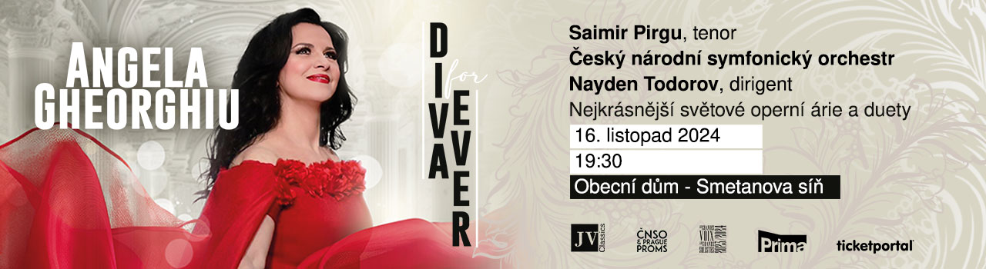
November 16, 2024, 7:30pm
Smetana Hall of the Municipal House, Prague
Angela Gheorghiu, returns to Prague after 11 long years to once again enchant her enthusiastic fans. She will perform the world's most beautiful operatic arias together with tenor Saimir Pirgu, accompanied by the Czech National Symphony Orchestra and conducted by Nayden Todorov.
Angela Gheorghiu, the world’s most glamorous and gifted opera star (New York Sun), was born in the small Romanian town Adjud. From early childhood it was obvious that she will become a singer, her destiny was music. She attended the Music High School in Bucharest and graduated from the National University of Music Bucharest. She studied with the remarkable music teacher Mia Barbu. Ms. Gheorghiu’s magnificent voice and dazzling stage presence have established her as a unique international opera superstar.
She made her international debut in 1992 at Covent Garden as Mimì in La bohème and in the same year made her debut at the Vienna State Opera. She debuted at the Metropolitan Opera in 1993, as Mimì. It was at the Royal Opera House Covent Garden that she first sang her much acclaimed Violetta in La Traviata in 1994, when for the first and last time in television and operatic history the BBC cleared out its schedules to broadcast the opera live. Since her Royal Opera debut she has appeared at the world’s leading opera houses and concert halls around the world, her repertory including, among others, Mimì in La bohème, Violetta in La traviata, Juliette (Roméo et Juliette), Nedda (Pagliacci), Adina (L’elisir d’amore), Amelia in Simon Boccanegra, Tosca, Magda (La rondine), Marguerite in Faust, Micaëla (Carmen), Liù (Turandot), Charlotte in Werther and Adriana Lecouvreur.
She has recorded widely for EMI Classics/Warner Classics and Decca and has received numerous international artistic honours, including La Médaille Vermeille de la Ville de Paris, the awards of Chevalier and Officier de l’Ordre des Arts et des Lettres, the Nihil Sine Deo decoration from King Michael I of Romania, the European Cultural Award for Music, the Victoire d'Honneur Award, multiple Gramophone awards and twice the Female Artist of the Year award at the Classical BRIT Awards.
Angela Gheorghiu played the title role in Benoît Jacquot’s film Tosca, which was enthusiastically received by the international press. She attended the launch of the film at the Venice Film Festival in 2001. She also sang Juliette in a film of Roméo et Juliette.
Angela Gheorghiu performed at the reopening gala of the Royal Opera House (1999) and of the Teatro Malibran in Venice (2001). She sang at the Queen Elizabeth II Golden Jubilee, on the grounds of Buckingham Palace (2002), and at the Nobel Peace Prize Concert (2003). Angela Gheorghiu also sang in concert for Pope John Paul II, at Castel Gandolfo (2002). In 2005, she sang at the opening of the Palau de les Arts Reina Sofia in Valencia, in the presence of Queen Sofia of Spain, and at the Queen Beatrix of the Netherlands Silver Jubilee Gala in Amsterdam. In 2007, she performs the role of Fanny in the world premiere of Vladimir Cosma’s Marius et Fanny in Marseille. In 2011 she sang at the reopening of the Bolshoi Theater in Moscow and at the grand opening of the Katara Amphitheater in Doha, Qatar, where she performs music especially composed for her by the legendary Greek composer Vangelis. She also sang for the Diamond Jubilee of HM Queen Elizabeth II in 2012, at the Royal Opera House. Angela Gheorghiu headlined the Last Night of the Proms concert in London on three different occasions, at the Royal Albert Hall (2003) and in Hyde Park (2000, 2006).
In October 2018, in London, she has launched her first autobiography – Angela Gheorghiu: A Life for Art, written together with Jon Tolansky.
In February 2021, Angela Gheorghiu has performed in aid of New York's Metropolitan Opera (Met) musicians, deprived of their pay because of virus-related cancellations of their shows, the proceeds benefitting over 150 Met musicians in need.
February 2022 marked her 30th anniversary with the Royal Opera House in London, where she reprised Tosca to great critical acclaim.
She has shared the stage with such stars as Andrea Bocelli, Placido Domingo, Luciano Pavarotti, Bryn Terfel, Rolando Villazon, Jonas Kaufman and Roberto Allagna.
In the history of opera, Angela Gheorghiu shines as a rare phenomenon: not only a singer/actress with an exceptional vocal technique and profound dramatic and musical intelligence, but also a magnetic communicator who penetrates the hearts and minds of a panoramic spectrum of audiences. She has brought the very highest values of operatic art to a vast worldwide community on an unusually broad scale.
Programem:
Georg Freidrich Haendel, Rinaldo - "Lascia ch'io pianga"
Georges Bizet, Carmen, « La fleur que tu m’avais jetée »
Giacomo Puccini, Tosca - "Mario, Mario"
Arrigo Boito, Mefistofele - L’altra notte in fondo al mare"
Giacomo Puccini, Tosca “E lucevan le stelle”
Giacomo Puccini, La Boheme - "O soave fanciulla"
Guiseppe Verdi, Un Ballo in Maschera - "Morro, ma prima in grazia"
Guiseppe Verdi, Ernani “Mercè, diletti amici… Come rugiada al cespite”
Umberto Giordano, Andrea Chenier - "Vicino a te"
Francesco Cilea, L’Arlesiana “È la solita storia del pastore”
Giacomo Puccini, Madama Butterfly - "Un bel di, vedremo"
Guiseppe Verdi, La Traviata - Brindisi "Libiamo"

Tickets on sale at Ticketportal.cz

