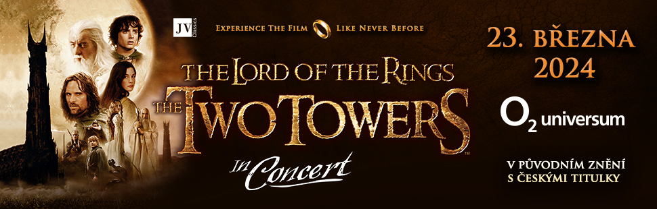

Lord of the Rings: The Two Towers in Concert
The Legend of the Ring continues!
23rd March 2024, 2:30pm, O2 universum Prague

THE PILGRIMAGE OF THE "FELLOWSHIP OF THE RING" CONTINUES ONCE AGAIN IN A UNIQUE FILM PERFORMANCE WITH LIVE MUSIC. HOBBITS, ELVES, ORCS AND DWARVES WILL COME TO LIFE ON A GIANT MOVIE SCREEN ACCOMPANIED BY A 230 MEMBER SYMPHONY ORCHESTRA, CHOIRS AND INTERNATIONAL SOLOISTS.
Due to huge audience demand following the 1st Lord of the Rings concert in December 2022, JV Classics presents the sequel to this epic fantasy - The Two Towers. Accompanied by a 230 member symphony orchestra, choir and international soloists, the spectacular projection will be performed on March 2024 at the modern O2 universum concert hall in Prague.
The Lord of the Rings: The Two Towers, based on the book by John Ronald Reuel Tolkien, premiered in the Czech Republic on 16 January 2003 and was attended by three quarters of a million people. Although 20 years have passed since its release, this ground-breaking work has not lost a bit of its huge popularity. On the contrary, more and more generations admire its excellence. The music for the trilogy was composed by famous Howard Shore: "The wide range of music requires a symphony orchestra, mixed choir, boys' choir and instrumental and vocal soloists singing in Tolkien's literary languages, but of course also in English", says the author.
The music of The Lord of the Rings is considered one of the most complex works in the field of film music. The styles and instruments from around the world illustrate and characterise the individual elements of Tolkien's saga. Most probably it will forever remain the most famous of Howard Shore's work, for which he received two Oscars (for The Fellowship of the Ring and The Return of the King). The third Oscar was awarded to the final song “Into the West”, sung by Annie Lennox.
"My first score for the Lord of the Rings trilogy, The Fellowship of the Ring, was the beginning of my journey into the world Tolkien and I will always hold a special fondness for the music and the experience," said Shore. His storytelling through music and melody evident here in full, creating a perfect second blueprint to the story.
Jackson and his production team of over 2,400 people, filming on location in New Zealand with the help of 26,000 extras, filmed all three parts at once. Starring in the film are Elijah Wood, Ian McKellen, Liv Tyler, Viggo Mortensen, Cate Blanchett, Orlando Bloom, Christopher Lee, Bernard Hill, Andy Serkis, Karl Urban, Hugo Weaving, and other Hollywood stars.
Tickets for The Lord of the Rings: The Two Towers are on sale from 2nd August 2023 at Ticketmaster and Ticketportal. The film will be screened in English with Czech subtitles.

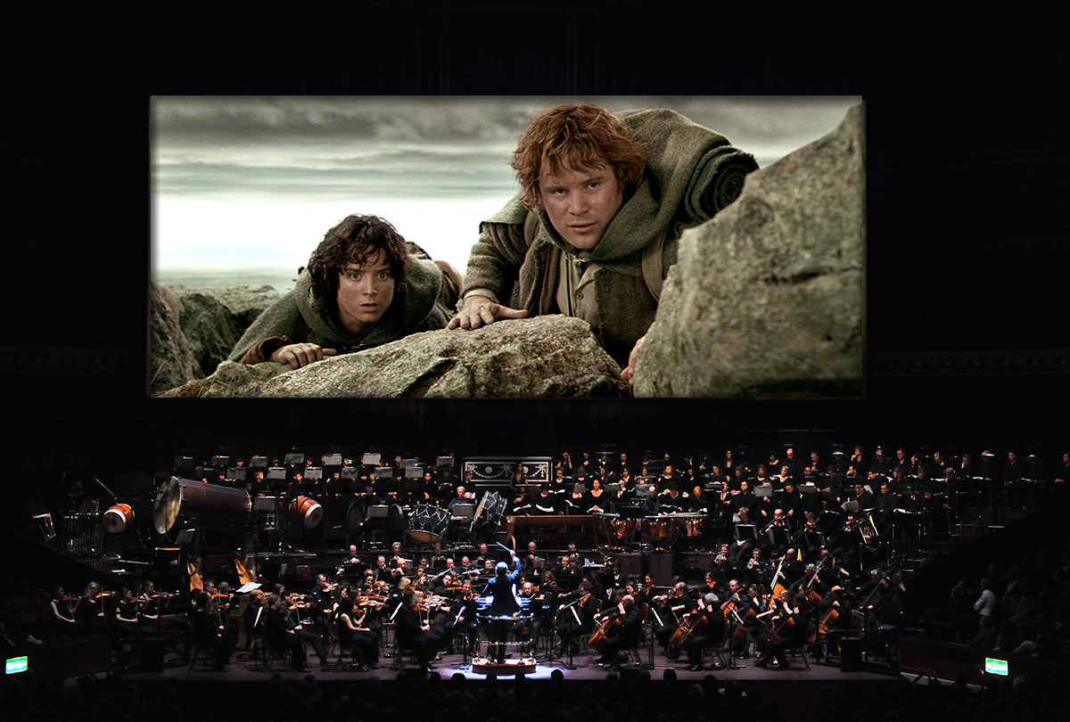

More info here: www.facebook.com/jvclassics or www.lordoftheringsinconcert.com

