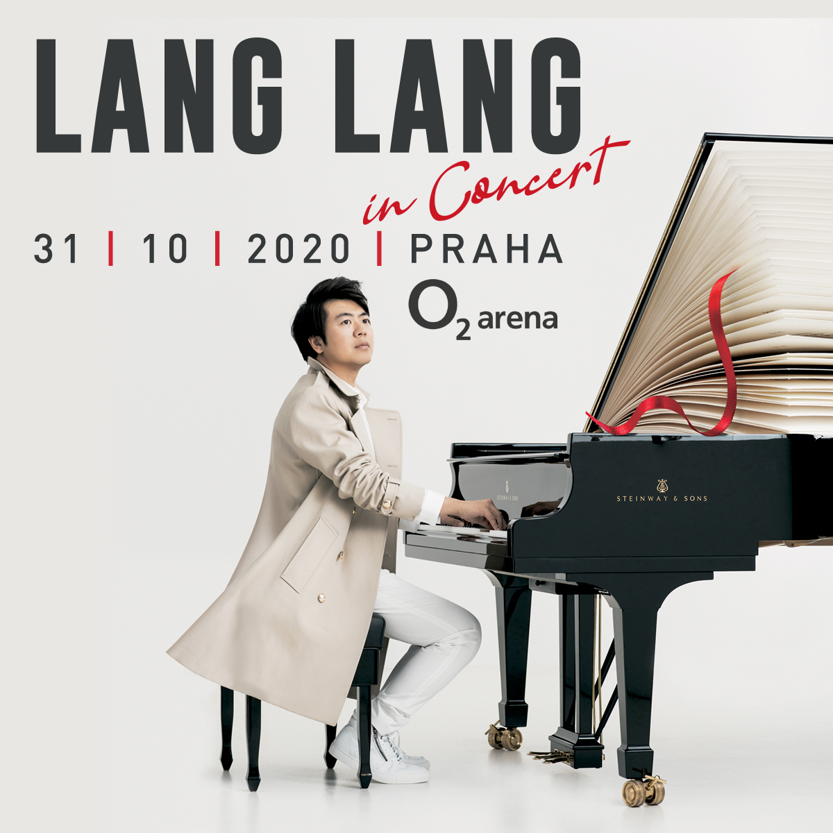

Lang Lang is a leading figure in classical music today–as a pianist, educator and philanthropist he has become one of the world’s most influential and committed ambassadors for the arts in the 21st century. Equally happy playing for billions of viewers at the 2008 Olympic Opening Ceremony in Beijing or just for a few hundred children in the public schools, he is a master of communicating through music. He was heralded by the New York Times as “the hottest artist on the classical music planet”.

Lang Lang plays sold-out concerts all over the world. He has formed ongoing collaborations with conductors including Sir Simon Rattle, Gustavo Dudamel, Daniel Barenboim and Christoph Eschenbach and performs with all the world’s top orchestras. Lang Lang is known for thinking outside the box and frequently steps into different musical worlds. His performances at the GRAMMY Awards with Metallica, Pharrell Williams or jazz legend Herbie Hancock were watched by millions of viewers. For about a decade Lang Lang has contributed to musical education worldwide.

In 2008 he founded the Lang Lang International Music Foundation aimed at cultivating tomorrow’s top pianists, championing music education at the forefront of technology, and building a young audience through live music experiences. In2013 Lang Lang was designated by the Secretary General of the United Nations as a Messenger of Peace focusing on global education. Lang Lang started playing the piano aged three, and gave his first public recital before the age of five. He entered Beijing’s Central Music Conservatory aged nine, and won First Prize at the International Tchaikovsky Competition for Young Musicians at 13. He subsequently went to Philadelphia to study with legendary pianist Gary Graffman at the Curtis Institute of Music. He was seventeen when his big break came, substituting for André Watts at the Gala of the Century, playing Tchaikovsky’s First Piano Concerto with the Chicago Symphony Orchestra under the baton of Christoph Eschenbach: he became an overnight sensation and the invitations started to pour in.

Lang Lang’s boundless drive to attract new audiences to classical music has brought him tremendous recognition: he was presented with the 2010 Crystal Award in Davos and was picked as one of the 250 Young Global Leaders by the World Economic Forum. He is also the recipient of honorary doctorates from the Royal College of Music, the Manhattan School of Music and New York University. In December 2011 he was honoured with the highest prize awarded by the Ministry of Culture of the People’s Republic of China and received the highest civilian honours in Germany (Merit of the Federal Republic of Germany) and France (Medal of the Order of Arts and Letters). In 2016 Lang Lang was invited to the Vatican to perform for Pope Francis. He has also performed for numerous other international dignitaries, including four US presidents and monarchs from many nations.
“The ebullient Lang Lang is maturing as an artist… his playing is refined, almost severe. He has an intelligent way of shaping phrases, controlling dynamics, varying articulations... a captivating performance, the kind that you remember as much for its quiet stretches as for its wow factor.
— New Yorker
“Lang the magician is slowly transforming himself into Lang the musician…there will be no stopping this nonchalant dervish of the keyboard . . .his playing was so raptly beautiful that one was afraid to breathe for fear of missing anything.
— Chicago Tribune

Tickets are on sale from 7th of August at Ticketportal. Price from 1.100 to 8.800,-Kč

Vladimíra Zahradníková
JV Classisc s.r.o
GSM: +420 602 386 673

